Any static manufacturing model resists change. These models are linear, mechanistic and focused on solid, static building blocks – it is levers, pulleys and buttons that implement change – just look at the simple genius of the assembly line. It guarantees increased production with perfect control over the system. But this manufacturing model always would and will resist change.
We all know that the older industrial model has been to a large degree replaced by the technological and information age. We are living in a constantly changing and ‘living’ business environment.
The ‘living’ business focuses on a global economy, ecology, holistic thinking, sustainability and a full system view with technology as the verve centre of this view. The ‘web’ helps us communicate better, access immense levels of information and gather knowledge – worldwide.
But take a look at Nature. This is probably the most effective model of change, seasonal change, species evolving – we have learned from nature – companies ‘live’ and companies ‘die’. What is certain is that success in business requires a real shift in perspective and new skill sets and behaviours.
The perspective shift is that management cannot make change happen in the mechanistic way of the old model. The new model allows change to evolve and requires a real relationship with change. This includes both the Manager AND the teams involved. It requires relationship rather than mechanical control and this shifts the focus from Management to Leadership. Managers and Business Owners need to have a healthy relationship with the principle of change. Here are a few questions and points for you as you embark on your change journey:
What changes do you make willingly?
Look at the changes you make daily, weekly and seasonally. You change your clothes before meetings, you change your schedule, you change your eating habits to lose a few pounds. You change jobs, location, marriages. You have partners, friends, co-workers, clients and children who change your life. You are in control of living and life. You KNOW how to change and do it as a natural part of living – you do it daily. These changes are planned or inspired by choice – the outcomes are expected, self-initiated, cyclic, understood, rational and patterned. We are all involved in a natural process of change.
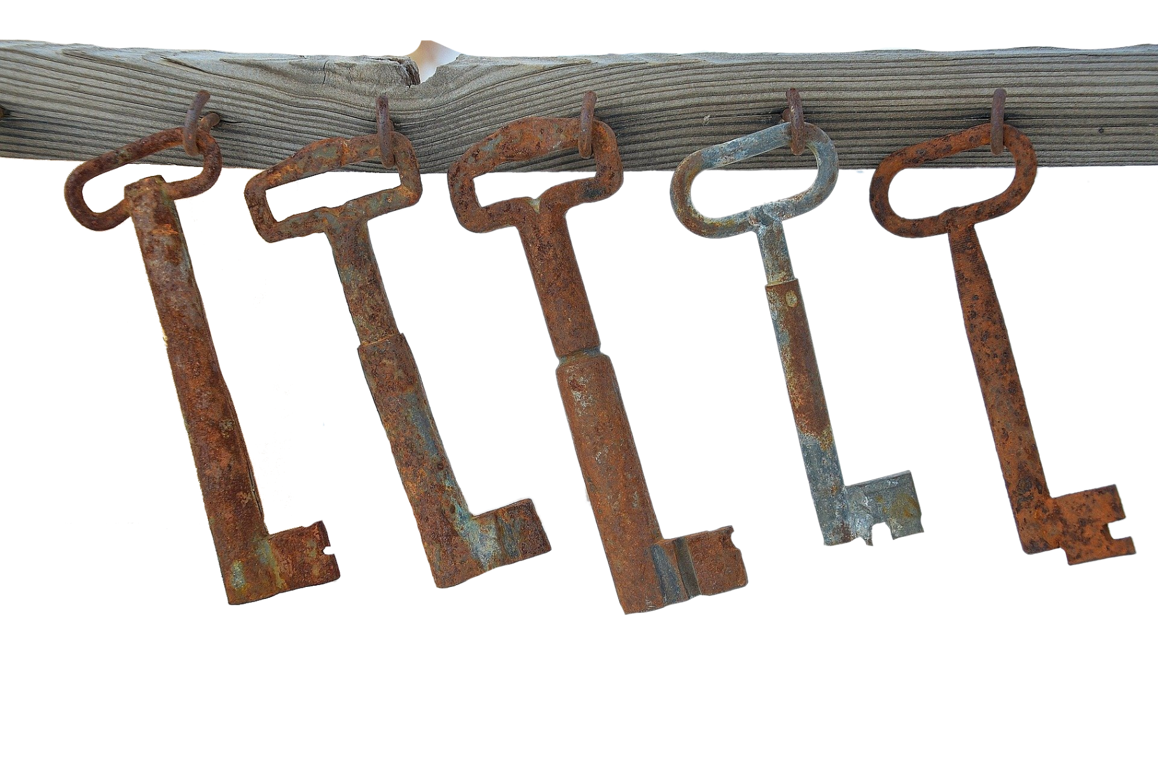

What changes do you resist?
The changes we find difficult are unexpected, sudden, imposed by others, seen as irrational or result in unknown outcomes. Random changes will create instability – you have no choice and you feel powerless. ‘Crisis management’ change is reactive rather than creative. Change is unwelcome when you must experience a loss or cannot see a positive outcome.
Change is much easier in a stable system. One element changes first then the next. Incremental changes are mush more successful when prioritised. If changes in a business seem forced or chaotic people will resist them.
Change the process of change within your business:
As individuals we discover an openness to change that is planned, expected, self-initiated, cyclic, understood, rational or patterned and that allows choice or involvement in the process – think about the involvement bit – very important! As individuals we know all of this but as business people we forget that change best happens most effectively with known steps and with communication. Within a business environment, the challenge is in encouraging individuals to collaborate on necessary changes. This change in perspective accelerates when leaders adopt behaviours that encourages a ‘living and changing process’.
The following are the LEADERSHIP KEY ELEMENTS that encourage a positive change environment:
KEY ELEMENT ONE: ENCOURAGE NEW IDEAS
The key to positive change involves risk and experimentation in areas of growth. If the culture does not support creativity and possibility, the old system stays in place. So be open to new ideas that others present to you or that you see in other markets and sectors. Develop flexibility and adaptability and bring it right into the work environment – reward rather than criticise new ideas. Doing so will solve problems as they arise. Eventually you will find that individual self-initiative will become an accepted group norm.
This element matches the human need for self-initiative and to understand change.
KEY ELEMENT TWO: CREATE TRUST AMONG CHANGE MEMBERS
The key to successful change is making it a group process of accepting new behaviours or learning new systems. Distrust generates negativity and a lack of communication. So, build respect and co-operation among your team to achieve the goals necessary and for change to be accepted. If the group does not trust each other, they spend their energy resisting new ideas. Collaboration and learning requires trust built through communication. Reward positive collaboration and refuse to accept competition, put-downs and breach of trust.

This concept matches the human need for rationality, planned change and involvement in the process.
KEY ELEMENT THREE: DEFINE ONLY THE FINAL GOAL
The key to self-initiated change is the team’s involvement in the design, Define only where you are heading – the destination. Allow the team to create the itinerary. For example, challenge the team to ‘cut costs in Manufacturing by 2% within 60 days.’ This tangible and measurable goal is given back to the team to solve, and they create consensus by achieving it. They will develop a consensus of methodology required to achieve the tangible goal.
This concept matches the human need for self-initiated change.
KEY ELEMENT FOUR: INITIATE A STABLE ENVIRONMENT WITH INCREMENTAL CHANGES
The key to the continual change process is clear priorities. Change one element at a time, but not everything simultaneously. When staggered in steps, change is more successful. This requires Leadership and clear goals – subjects that we cover extensively in the Academy material. Complete one of the series of change before you start the next. If you try to change everything at once the result is a dangerous ‘juggling act’ with unexpected outcomes. The chaos generates resistance.
This concept matches the human need for cyclic or patterned change.
KEY ELEMENT FIVE: INSTILL A CLEAR VISION, PURPOSE AND VALUES WITHIN THE COMPANY
This is the key for leaders who tend to file their vision and purpose statement in the bottom draw or worse do not have one. It requires close scrutiny in terms of how the changes planned have close synergy with the vision and purpose of the business. If they don’t the changes are not appropriate. The process of defining Vision and Purpose and Values should define the changes required within the whole company to achieve them. This creates an alignment for all of the company. The team knows what needs to be changed in order to align with the company vision, purpose and values. Vision and Purpose are long range goals and the changes you make are each a short step towards these. View the Vision and Purpose as the ‘guiding star’ and each change made as a mountain climbed on the journey. Re-enforcing the company values regularly is a great way of aligning how change is happening within the business. The accepted process of change becomes understood by the team.
This concept matches the human need for rational and known outcomes.

SUMMARY: LEADERSHIP IS THE KEY TO THE PROCESS OF CHANGE
Change is defined as ‘exchanging one thing for another’ and known outcomes are more easily accepted. After all it isn’t easy to exchange one known quantity for an unknown quantity. For a business leader in the process of change you need to identify what needs to be changed and what must stay the same. Leadership requires knowing what goals to achieve and knows how to allow the team to collaborate on how to achieve them. Then define the priorities so the changes are incremental. The team becomes the ‘change Agent’ as a result. The group then make changes willingly because they initiate the process for a known outcome.
Additionally, team members must understand WHY the change is necessary. Convince the change members that the goal is achievable and not a moving target. Delegate choices to the members and then align with values and outcomes required. Remember change is easier when we create the process and move toward an outcome or goal that is understood. The more we contribute to the methodology of the change. the more we align with the goal.
Engage your team members in the implementation process. Ensure that they trust each other and communicate effectively and openly to discuss the pros and cons of all scenarios. You can then address their fears of the unknown and move in the right direction for the best long-term outcome. The more positive factors in your business that help the change process, the higher will be your change success rate in a designed change.
What you get from this work is an empowered, flexible and responsive team. The pressures of markets now require the strength of a resilient and committed team within your business. A team committed to achieve objectives. As we covered earlier human potential is never optimised on an assembly line – we optimise human potential through involvement, learning and communication. We will willingly make changes in our lives when inspired and making choices – make this possible within your business too. Take risks and implement empowered changes in your business – the rewards will make the risk well worthwhile.

