The Balanced Scorecard is a useful tool that establishes the strategic direction for the company and provides the ability to monitor any strategic decisions.

The strategic objectives should cover at least four critical business performance areas – these being:
- Financial
- Customer
- Internal processes
- Learning & growth.

To get started take the following steps:
- Establish a clear vision of the future.
- Define the strategic objectives that underpin this vision.
- Determine the critical success factors that are necessary to achieve.
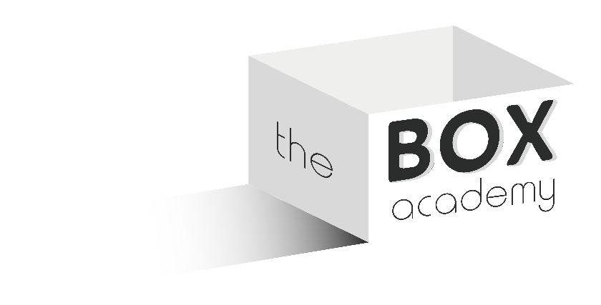
- Choose indicators to measure and monitor performance – benchmarks.
- Set goals, action plans, and initiatives to support the programme.

