Assessment Toolkit - Leadership
This is a very useful tool to establish where you sit as an organisation in terms of leadership both now and potentially in the future.
A useful suggestion here is to send the questions around to your Board or team of Key Managers and get them to respond and total their scores. Then compare their thoughts with yours and take note. If you are much more positive than your team it may well be that the reality isn’t as you see it.
Scores of below 20 here indicate that you have a major problem in terms of leadership skills and growing leaders within your business and only if a score of 40 plus is registered can you feel that you are doing a good job. Work on the weaker aspects immediately and remember that the best performing businesses put a priority against management and leadership training.

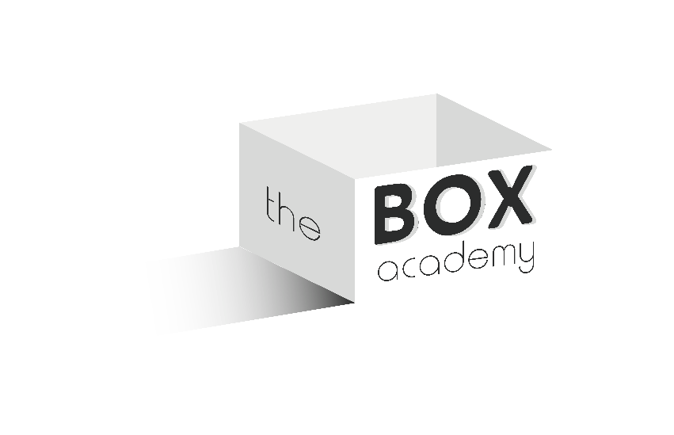
Assessment Guide
Total Score | Guide
0 - 10 | You are showing all of the signs of an autocratic, ‘tentacle’ style of management where all responsibility and decisions probably rest at the very top. Without significant change your business will find it very hard to develop and you will also really struggle to hire and or retain good people. You need to act now.
11 – 20 | Plenty of work to do here although you may have some areas fairly well covered off. You still fall well short of an acceptable standard however and to compete with top quality competition you need to up your game in this area.
21 – 30 | Some really promising signs but clear areas of weakness too. Focus on improving the weaker areas and see team motivation and enthusiasm build.
31 – 40 | You have a lot that is going the right way but you need to complete the package to create real momentum and get all of your people ‘on the bus’. You should already be seeing some good results in people development and skill uptake within your business.
41 - 50 | Top draw! Not much that is missing here! A word of caution – have you truly been honest? If so – congratulations to you and your team.

Mark the scale as honestly as you can.

- Our managers are encouraged to take risks and try new ideas. | Click to select from list
- We are good at spotting opportunities that lead to improved performance. | Click to select from list
- We constantly discuss and plan for the future. | Click to select from list
- Everybody has a commitment to our future plans. | Click to select from list
- Managers delegate meaningful tasks in a way of developing and improving individual performance. | Click to select from list
- Everyone is involved in the planning process. | Click to select from list
- Our managers act as role models and lead by example | Click to select from list
- Our managers understand what motivates individuals within their team. | Click to select from list
- We communicate our successes throughout the organisation. | Click to select from list
- Leadership exists and is encouraged at all levels within Sales and Operations. | Click to select from list
INPUT TOTAL HERE: | 0

