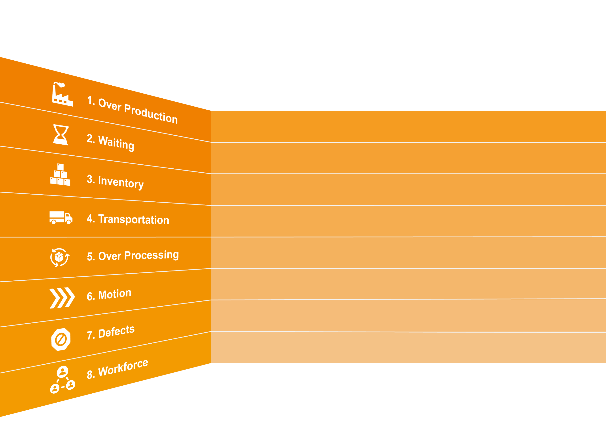
How much time do you spend finding and fixing product mistakes?
Do you work on the product too many times or otherwise work inefficiently on it?
(Work in Progress/ WIP) – are these levels too high?
Do people and equipment move between tasks efficiently?
Are they used efficiently and effectively?
Are materials moved efficiently?
How much ‘downtime’ is there between Production steps?
Are you producing more than demand?
